Passion Project – Sonia Serrano

I would like to do my passion project on a Pizza Store. I will be using 3 tables:

1. Customers
2. Orders
3. Employees

Database Entity Relationship (ERD)

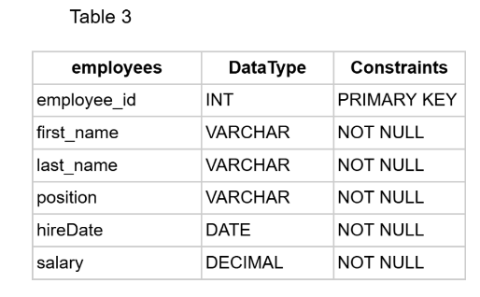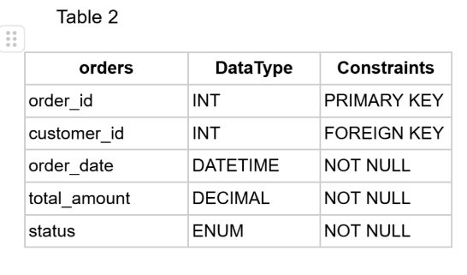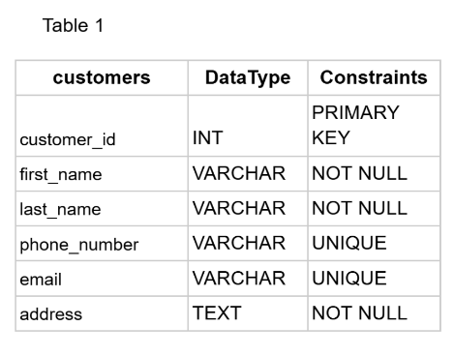



Customer – A customer can have multiple Orders ( one to many relationships)

Employee – An Employee can handle multiple orders (one to many relationships)

Customers and Employees ( many to many relationships)

Created Wireframes on a separate sheet of paper

Created links to Customers, Orders, and Employees. CRUD forms for each entity. Order page includes dropdowns to select customer and employee.

For customer wireframe will contain a add, edit and delete customer button. For Order wireframe will contain a create, update, delete order and employee button. For employees wireframe add, edit and delete employee.

**Customer API Methods**:

GET /api/customers: Fetch a list of all customers.

POST /api/customers: Create a new customer.

PUT /api/customers/{id}: Update customer details.

DELETE /api/customers/{id}: Remove a customer.

**Orders API Methods**:

GET /api/orders: Fetch all orders with customer and employee details.

POST /api/orders: Create a new order.

PUT /api/orders/{id}: Update an order (change customer/employee).

DELETE /api/orders/{id}: Remove an order.

**Employees API Methods**:

GET /api/employees: Fetch all employees.

POST /api/employees: Create a new employee.

PUT /api/employees/{id}: Update employee details.

DELETE /api/employees/{id}: Remove an employee.